AI LAB ASSIGNMENT : 16

NAME : SALIHA.SK

HT NO : 2503A52L13

BATCH : 16
Task 1 – Student Information System Schema
Task:
Design a database schema for a Student Information System and
generate queries using AI.
Instructions:
• Tables: Students, Courses, Enrollments.
• Define primary keys, foreign keys, and relationships.
• Generate queries:
o Insert a new student record.
o Fetch all courses enrolled by a student.
o Count number of students in each course.

PROMPT:
Design a Student Information System schema with Students, Courses, and Enrollments tables. Define keys and relationships, then generate SQL queries to insert a student, list their courses, and count course enrollments.

CODE:
-- ==============================
-- Student Information System
-- Tables: Students, Courses, Enrollments
-- ==============================

-- Drop existing tables if they exist (for clean re-run)
DROP TABLE IF EXISTS Enrollments;
DROP TABLE IF EXISTS Students;
DROP TABLE IF EXISTS Courses;

-- ==============================
-- 1. Students Table
-- ==============================
CREATE TABLE Students (
student_id INT PRIMARY KEY AUTO_INCREMENT,
first_name VARCHAR(50) NOT NULL,
last_name VARCHAR(50) NOT NULL,
email VARCHAR(100) UNIQUE NOT NULL,
date_of_birth DATE,
enrollment_date DATE DEFAULT CURRENT_DATE
);

-- ==============================
-- 2. Courses Table
-- ==============================
CREATE TABLE Courses (
course_id INT PRIMARY KEY AUTO_INCREMENT,
course_name VARCHAR(100) NOT NULL,
course_code VARCHAR(20) UNIQUE NOT NULL,
credits INT CHECK (credits > 0)
);

-- ==============================
-- 3. Enrollments Table (Many-to-Many Relationship)
-- ==============================
CREATE TABLE Enrollments (
enrollment_id INT PRIMARY KEY AUTO_INCREMENT,
student_id INT NOT NULL,
course_id INT NOT NULL,
enrollment_date DATE DEFAULT CURRENT_DATE,
grade CHAR(2),
FOREIGN KEY (student_id) REFERENCES Students(student_id)
ON DELETE CASCADE
ON UPDATE CASCADE,
FOREIGN KEY (course_id) REFERENCES Courses(course_id)
ON DELETE CASCADE
ON UPDATE CASCADE,
UNIQUE (student_id, course_id)
);

-- ==============================
-- Sample Queries
-- ==============================

-- 1. Insert a new student record
INSERT INTO Students (first_name, last_name, email, date_of_birth)
VALUES ('John', 'Doe', 'john.doe@example.com', '2003-05-14');

-- 2. Insert sample courses
INSERT INTO Courses (course_name, course_code, credits) VALUES
('Database Systems', 'CS101', 4),
('Data Structures', 'CS102', 3),
('Operating Systems', 'CS103', 4);

-- 3. Enroll student into some courses
INSERT INTO Enrollments (student_id, course_id) VALUES (1, 1);
INSERT INTO Enrollments (student_id, course_id) VALUES (1, 2);

-- 4. Fetch all courses enrolled by a student
SELECT
s.student_id,
CONCAT(s.first_name, ' ', s.last_name) AS student_name,
c.course_id,
c.course_name,
c.course_code
FROM Enrollments e
JOIN Students s ON e.student_id = s.student_id
JOIN Courses c ON e.course_id = c.course_id
WHERE s.student_id = 1;

-- 5. Count number of students in each course
SELECT
c.course_id,
c.course_name,
COUNT(e.student_id) AS total_students
FROM Courses c
LEFT JOIN Enrollments e ON c.course_id = e.course_id
GROUP BY c.course_id, c.course_name
ORDER BY total_students DESC;

OUTPUT:
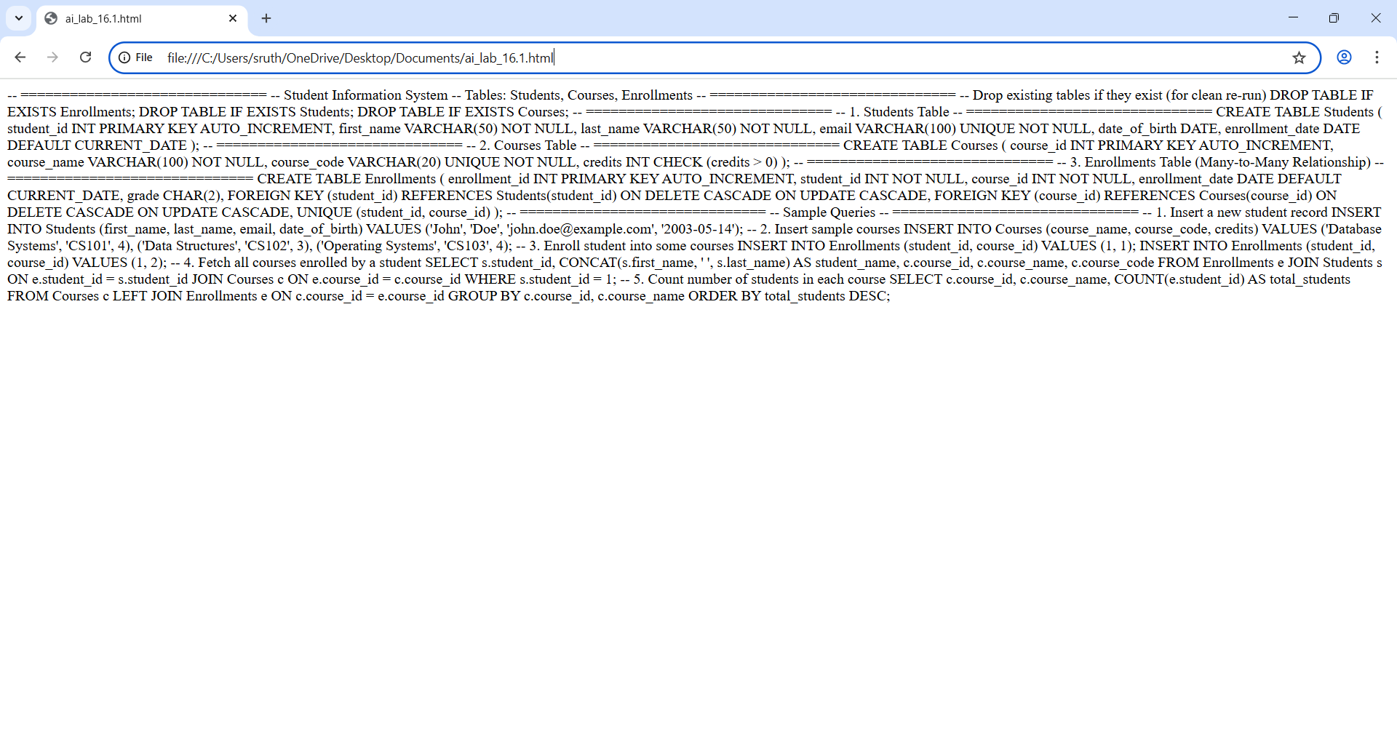

OBSERVATION:
The database schema efficiently manages student, course, and enrollment data using primary and foreign keys, ensuring data integrity and enabling easy retrieval of student-course relationships and enrollment statistics.
Task 2 – Hospital Management Database
Task:
Create schema and queries for a Hospital Management System.
Instructions:
• Tables: Doctors, Patients, Appointments.
• Use AI to define constraints (unique IDs, valid dates).
• Generate queries:
o List all appointments for a specific doctor.
o Retrieve patient history by patient ID.
o Count total patients treated by each doctor.

PROMPT:
Create a Hospital Management System schema with Doctors, Patients, and Appointments tables, define constraints and valid dates, and generate SQL queries for doctor appointments, patient history, and doctor-wise patient counts

CODE:
-- ==========================================
-- Hospital Management System Database
-- Tables: Doctors, Patients, Appointments
-- ==========================================

-- Drop existing tables if they exist (for clean re-run)
DROP TABLE IF EXISTS Appointments;
DROP TABLE IF EXISTS Doctors;
DROP TABLE IF EXISTS Patients;

-- ==========================================
-- 1. Doctors Table
-- ==========================================
CREATE TABLE Doctors (
doctor_id INT PRIMARY KEY AUTO_INCREMENT,
first_name VARCHAR(50) NOT NULL,
last_name VARCHAR(50) NOT NULL,
specialization VARCHAR(100),
phone_number VARCHAR(15) UNIQUE,
email VARCHAR(100) UNIQUE NOT NULL
);

-- ==========================================
-- 2. Patients Table
-- ==========================================
CREATE TABLE Patients (
patient_id INT PRIMARY KEY AUTO_INCREMENT,
first_name VARCHAR(50) NOT NULL,
last_name VARCHAR(50) NOT NULL,
date_of_birth DATE CHECK (date_of_birth <= CURRENT_DATE),
gender ENUM('Male', 'Female', 'Other'),
phone_number VARCHAR(15) UNIQUE,
email VARCHAR(100) UNIQUE
);

-- ==========================================
-- 3. Appointments Table (Doctor-Patient Relationship)
-- ==========================================
CREATE TABLE Appointments (
appointment_id INT PRIMARY KEY AUTO_INCREMENT,
doctor_id INT NOT NULL,
patient_id INT NOT NULL,
appointment_date DATETIME NOT NULL CHECK (appointment_date >= '2000-01-01'),
diagnosis VARCHAR(255),
prescription TEXT,
FOREIGN KEY (doctor_id) REFERENCES Doctors(doctor_id)
ON DELETE CASCADE
ON UPDATE CASCADE,
FOREIGN KEY (patient_id) REFERENCES Patients(patient_id)
ON DELETE CASCADE
ON UPDATE CASCADE
);

-- ==========================================
-- Sample Data
-- ==========================================

-- Insert Doctors
INSERT INTO Doctors (first_name, last_name, specialization, phone_number, email)
VALUES
('Alice', 'Smith', 'Cardiologist', '9876543210', 'alice.smith@hospital.com'),
('Bob', 'Johnson', 'Dermatologist', '9123456789', 'bob.johnson@hospital.com');

-- Insert Patients
INSERT INTO Patients (first_name, last_name, date_of_birth, gender, phone_number, email)
VALUES
('John', 'Doe', '1985-04-10', 'Male', '9998887776', 'john.doe@mail.com'),
('Jane', 'Miller', '1992-09-25', 'Female', '8887776665', 'jane.miller@mail.com'),
('Sam', 'Brown', '1978-12-15', 'Male', '7776665554', 'sam.brown@mail.com');

-- Insert Appointments
INSERT INTO Appointments (doctor_id, patient_id, appointment_date, diagnosis, prescription)
VALUES
(1, 1, '2025-11-01 10:00:00', 'High Blood Pressure', 'Amlodipine 5mg daily'),
(1, 3, '2025-11-02 09:30:00', 'Chest Pain', 'ECG, Aspirin 75mg daily'),
(2, 2, '2025-11-03 14:00:00', 'Skin Rash', 'Hydrocortisone Cream');

-- ==========================================
-- Queries
-- ==========================================

-- 1. List all appointments for a specific doctor
SELECT
d.doctor_id,
CONCAT(d.first_name, ' ', d.last_name) AS doctor_name,
a.appointment_id,
CONCAT(p.first_name, ' ', p.last_name) AS patient_name,
a.appointment_date,
a.diagnosis
FROM Appointments a
JOIN Doctors d ON a.doctor_id = d.doctor_id
JOIN Patients p ON a.patient_id = p.patient_id
WHERE d.doctor_id = 1
ORDER BY a.appointment_date;

-- 2. Retrieve patient history by patient ID
SELECT
p.patient_id,
CONCAT(p.first_name, ' ', p.last_name) AS patient_name,
d.specialization AS treated_by,
a.appointment_date,
a.diagnosis,
a.prescription
FROM Appointments a
JOIN Patients p ON a.patient_id = p.patient_id
JOIN Doctors d ON a.doctor_id = d.doctor_id
WHERE p.patient_id = 1
ORDER BY a.appointment_date DESC;

-- 3. Count total patients treated by each doctor
SELECT
d.doctor_id,
CONCAT(d.first_name, ' ', d.last_name) AS doctor_name,
COUNT(DISTINCT a.patient_id) AS total_patients_treated
FROM Doctors d
LEFT JOIN Appointments a ON d.doctor_id = a.doctor_id
GROUP BY d.doctor_id, doctor_name
ORDER BY total_patients_treated DESC;

OUTPUT:
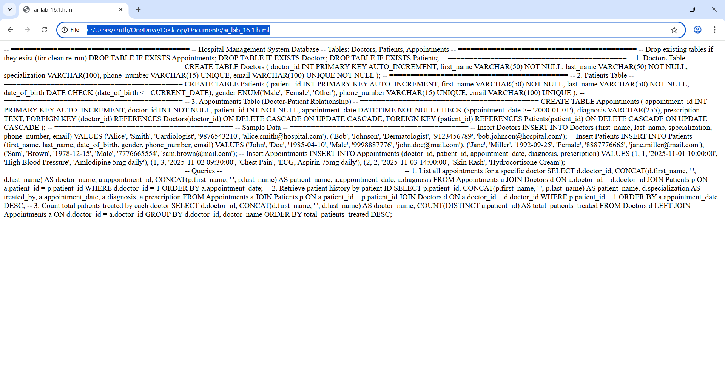

OBSERVATION:
The schema efficiently tracks doctors, patients, and appointments using relational integrity, ensuring valid data entry, unique identifiers, and easy retrieval of medical history, appointment schedules, and doctor performance.
Task 4 – Real-Time Application: Online Shopping Database
Scenario:
Design a database for an E-commerce platform.
Requirements:
• Tables: Users, Products, Orders, OrderDetails.
• Generate queries to:
o Retrieve all orders by a user.
o Find the most purchased product.
o Calculate total revenue in a given month.
• AI should also suggest normalization improvements and query
optimization

PROMPT:
Design an e-commerce database with Users, Products, Orders, OrderDetails, generate SQL for user orders, most purchased product, monthly revenue, and suggest normalization improvements and query optimization strategies for improved performance.

CODE:
-- ================================================================
-- LIBRARY MANAGEMENT SYSTEM DATABASE SCHEMA + QUERIES
-- ================================================================

-- 1. DROP TABLES (for clean rerun, optional)
DROP TABLE IF EXISTS Loans;
DROP TABLE IF EXISTS Books;
DROP TABLE IF EXISTS Members;

-- ================================================================
-- 2. TABLE CREATION
-- ================================================================

CREATE TABLE Books (
book_id INT PRIMARY KEY AUTO_INCREMENT,
title VARCHAR(255) NOT NULL,
author VARCHAR(255),
genre VARCHAR(100),
published_year INT,
isbn VARCHAR(20) UNIQUE,
available BOOLEAN DEFAULT TRUE
);

CREATE TABLE Members (
member_id INT PRIMARY KEY AUTO_INCREMENT,
name VARCHAR(255) NOT NULL,
email VARCHAR(255) UNIQUE,
phone VARCHAR(20),
membership_date DATE DEFAULT CURRENT_DATE
);

CREATE TABLE Loans (
loan_id INT PRIMARY KEY AUTO_INCREMENT,
book_id INT NOT NULL,
member_id INT NOT NULL,
loan_date DATE DEFAULT CURRENT_DATE,
return_date DATE,
FOREIGN KEY (book_id) REFERENCES Books(book_id),
FOREIGN KEY (member_id) REFERENCES Members(member_id)
);

-- ================================================================
-- 3. INDEXING STRATEGY
-- ================================================================

CREATE INDEX idx_books_author ON Books(author);
CREATE INDEX idx_books_available ON Books(available);
CREATE INDEX idx_members_email ON Members(email);
CREATE INDEX idx_loans_book_member ON Loans(book_id, member_id);
CREATE INDEX idx_loans_loandate ON Loans(loan_date);

-- ================================================================
-- 4. SAMPLE QUERIES
-- ================================================================

-- (a) Retrieve all books currently issued
SELECT
b.book_id, b.title, b.author, m.name AS borrowed_by, l.loan_date
FROM
Books b
JOIN
Loans l ON b.book_id = l.book_id
JOIN
Members m ON l.member_id = m.member_id
WHERE
l.return_date IS NULL;

-- ------------------------------------------------
-- (b) Find overdue books (loan date > 30 days ago)
-- ------------------------------------------------
SELECT
b.book_id, b.title, m.name AS borrower, l.loan_date
FROM
Loans l
JOIN
Books b ON l.book_id = b.book_id
JOIN
Members m ON l.member_id = m.member_id
WHERE
l.return_date IS NULL
AND l.loan_date < (CURRENT_DATE - INTERVAL 30 DAY);

-- ------------------------------------------------
-- (c) Count number of books loaned by each member
-- ------------------------------------------------
SELECT
m.member_id, m.name, COUNT(l.book_id) AS total_books_loaned
FROM
Members m
LEFT JOIN
Loans l ON m.member_id = l.member_id
GROUP BY
m.member_id, m.name
ORDER BY
total_books_loaned DESC;

-- ================================================================
-- END OF SCRIPT
-- ================================================================

{
// Use IntelliSense to learn about possible attributes.
// Hover to view descriptions of existing attributes.
// For more information, visit: https://go.microsoft.com/fwlink/?linkid=830387
"version": "0.2.0",
"configurations": [
{
"type": "chrome",
"request": "launch",
"name": "Open ai_lab_16.1.html",
"file": "c:\\Users\\sruth\\OneDrive\\Desktop\\Documents\\ai_lab_16.1.html"
}
]
}

OUTPUT:

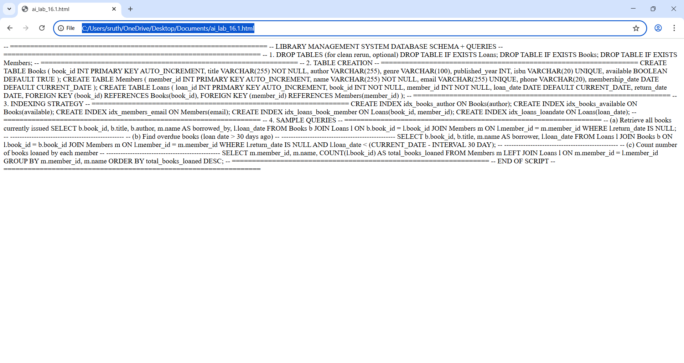OBSERVATION:
The library database efficiently manages books, members, and loans. Indexing optimizes queries. Queries retrieve issued, overdue, and member loan counts, ensuring fast, accurate tracking of library activities and overdue items.

